Online Book Store Project
July 2015

A. General Information

Prepared by: | Kinga Kimbrel
Date: | 7/15/15

B. Project Overview

An online book store has been designed as a virtual store on the Internet where customers can browse the catalog and select books of interest. The selected books may be collected in a shopping cart. At checkout time, the items in the shopping cart will be presented as an order. At that time, more information will be needed to complete the transaction. Usually, the customer will be asked to fill a shipping address. A notification is presented to the customer as soon as the order is placed.

C. Assumptions and Constraints

Constraints:
- staff availability
- 25% of project must be finished within 10 days, 100% within 50 days

Assumptions:
- One software developer and one tester will be avaliable during the entire project
- For first 10 days one extra software developer will work on the project

D. Resource Requirements

- Staff resources
- Tools to support communications, databases, etc.

F. Requirements

Technical requirements

System will be developed using ASP.NET MVC 5 technology along with WCF 4.0 and MS SQL Server 2012

Usability requirements
- The system will fully function in major browser
- The system will support mobile users in some way

Functional requirements
- Users can view books and filter them by category
- Users can collect books in shopping cart and place order after reviewing it
- Admin can monitor, edit, add and delete books from catalog.
- Admin can view orders and information provided by customers

E. Use Cases

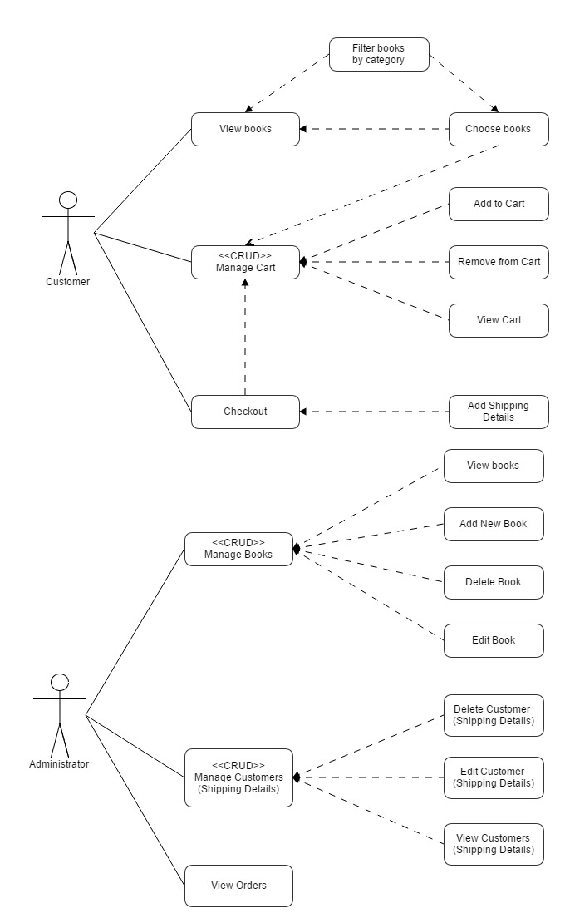

Manage Cart

Significance: | high
Type of use case: | general, essential
Actors: | Customer
Short description: | Customers can browse the catalog and select books of interest. The selected books may be collected and browsed in a shopping cart, Customers can remove items from cart and change quantity of selected books.
Pre-conditions: | At least one book has to be collected in a shopping cart.
Final conditions: | Proceeding to checkout.
Basic flow: | 1a. Customer chooses option Shopping cart.  1b. System shows list of selected books.  1c. Customer chooses option Checkout.
Alternative flow: | 2a. Customer changes quantity of selected books in a shopping cart choosing option Remove.  2b. System updates subtotal and total price for all items.  3a. Customer deletes books from a shopping cart choosing option Remove.  3b. System updates list of selected books and total price.
Special requirements: | System must work in real time and maximum respond time should be not longer than 5 sec.
Notes: | If customer leaves the website content of a shopping cart has to be cleared.

Manage Books

Significance: | high
Type of use case: | general, essential
Actors: | Administrator
Short description: | Administrator can browse, edit, remove books from the catalog and add new ones.
Pre-conditions: | Administrator has to be logged to Admin Panel.
Final conditions: | - New book is added to the catalog.  - Exisiting book is edited.  - Exisiting book is deleted.
Basic flow: | 1a. Admin chooses option Add new book.  1b. System shows form to fill out.  1c. After filling the form out Admin chooses option Save.
Alternative flow: | 2a. Admin selects a book and chooses option Edit.  2b. Admin updates details regarding selected book.  2c. Admin confirm changes by clicking Save option.  3a. Admin selects a book and chooses option Delete.  3b. System removes selected book from database.

Manage Customers

Significance: | high
Type of use case: | general, essential
Actors: | Administrator
Short description: | Administrator can browse, edit, remove customer information.
Pre-conditions: | At least one order has to be placed.
Final conditions: | Exisiting customer information is edited.
Basic flow: | 1a. Admin chooses option Customers from menu.  1b. System shows list of customer informations.  1c. Admin selects one customer information by choosing option Details.  1d. Admin updates details regarding selected customer.  1e. Admin confirm changes by clicking Save option.
Alternative flow: | 2a. Admin chooses option Customers from menu.  2b. System shows list of customer informations.  2c. Admin attempts to delete customer information by choosing option Delete.  2d. System shows warning that deleting is impossible due to existing order bounded to selected customer.

G. Database model

